# Lab: Creating Bookhut Web Site using Servlets and JSP

This **tutorial** provides step-by-step guidelines to build a **“Bookhut” app** in Java, Servlets, JSP and JSTL. The app should implement **home** / **sing up** / **sing in** / **add-book** / **shelves** pages. No database will be used.

## Project Specification

Design and implement a **“Bookhut” web application** in Java, Servlets, JSP and JSTL. Create 5 **JSP** pages with the following functionality:

* **Home**
  + Home page of the bookhut site
  + Should be able to redirect to all other pages
* **Sign Up**
  + Register a new user
* **Sign In**
  + In case of success, a session should be created.
  + Sign out option that will **invalidate** the session
* **Add Book**
  + Simple page to create new books
* **Shelves**
  + Page that will **list** all the books
  + Has possibility to **edit** each book
  + Has possibility to **delete** each book

## Project Setup

Create a new maven project called Bookhut. Add Java EE Web Application Framework support to the project. This is a recommended pom file:

|  |
| --- |
| **pom.xml** |
| <**properties**>  <**maven.compiler.source**>1.8</**maven.compiler.source**>  <**maven.compiler.target**>1.8</**maven.compiler.target**> </**properties**>  <**dependencies**>  <**dependency**>  <**groupId**>javax</**groupId**>  <**artifactId**>javaee-api</**artifactId**>  <**version**>7.0</**version**>  </**dependency**>  <**dependency**>  <**groupId**>jstl</**groupId**>  <**artifactId**>jstl</**artifactId**>  <**version**>1.2</**version**>  </**dependency**>  <**dependency**>  <**groupId**>org.modelmapper</**groupId**>  <**artifactId**>modelmapper</**artifactId**>  <**version**>0.7.5</**version**>  </**dependency**> </**dependencies**> |

## Create Models

Create two main entities for the application:

* **User**
  + Id
  + Username
  + Password
* **Book**
  + Id
  + Title
  + Author
  + Pages
  + Creation Date

We would need **three models** that will serves as **DTO**.

**Binding Models:**

* **LoginModel**
  + Username
  + Password
* **AddBookModel**
  + Title
  + Author
  + Pages

**View Models:**

* **ViewBookModel**
  + Title
  + Author
  + Pages

**Here is an overview of the model structure:**

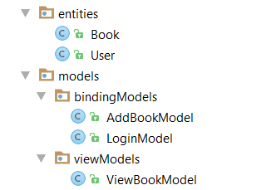

## Create Repositories

For this project **no database is required**. Use simple list implementation to store data.

Create two repositories:

* User Repository

|  |
| --- |
| **UserRepository.java** |
| **public interface** UserRepository {   **void** createUser(User user);   User findByUsernameAndPassword(String username, String password); } |

* Book Repository

|  |
| --- |
| **BookRepository.java** |
| **public interface** BookRepository {   **void** saveBook(Book book);   List<Book> getAllBooks();   **void** deleteBookByTitle(String title);   Book findBookByTitle(String title); } |

**In order to have a single instance of the lists use Singleton Pattern:**

|  |
| --- |
| **BookRepositoryImpl.java** |
| **public class** BookRepositoryImpl **implements** BookRepository {   **private static** BookRepositoryImpl *bookRepository*;   **private** List<Book> **books**;   **private** BookRepositoryImpl() {  **this**.**books** = **new** ArrayList<>();  }   **public static** BookRepository getInstance() {  **if** (*bookRepository* == **null**) {  *bookRepository* = **new** BookRepositoryImpl();  }   **return** *bookRepository*;  } } |

## Create Services

You would need a services for each that will transform entities to models and the other way around. Use **Model Mapper**.

Two services are required:

* **User Service**

|  |
| --- |
| **UserService.java** |
| **public interface** UserService {   **void** createUser(LoginModel loginModel);   LoginModel findByUsernameAndPassword(String username, String password); } |

* **Book Service**

|  |
| --- |
| **BookService.java** |
| **public interface** BookService {   **void** saveBook(AddBookModel addBookModel);   List<ViewBookModel> getAllBooks();   ViewBookModel findBookByTitle(String title);   **void** deleteBookByTitle(String title); } |

## Create Home Page

Home page should be **blank with simple menu**.

#### 5.1 Create menu.jsp

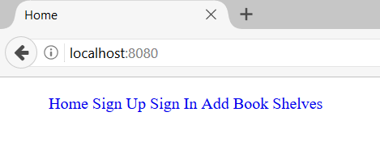

* Home – should redirect to “/”
* SignUp – should redirect to “/singup”
* SignIn – should redirect to “/singin”
* Add Book – should redirect to “/add”
* Shelves – should redirect to “/shelves”

#### 5.2 Create home.jsp

Include the created menu:

|  |
| --- |
| **home.jsp** |
| <%@ **page contentType**="**text/html;charset=UTF-8**" **language**="**java**" %> <**html**>  <**head**>  <**title**>Home</**title**>  </**head**>  <**body**>  <**jsp:include page="menu.jsp"**></**jsp:include**>  </**body**> </**html**> |

#### Create Home Controller Servlet

|  |
| --- |
| **HomeController.java** |
| @WebServlet(**""**) **public class** HomeController **extends** HttpServlet {   **protected void** doGet(HttpServletRequest request, HttpServletResponse response) **throws** ServletException, IOException {  request.getRequestDispatcher(**"templates/home.jsp"**).forward(request,response);  } } |

## Create Sing Up Page

Create Sign Up page that listen to route **/singup**. It should **store a new User** in the list which we use as a database. The **get request** should return a **signup.jsp with a simple form in it**.The post method should read the form parameters, create a new user and redirect to **/signin**.

|  |
| --- |
| **SingUpController.java** |
| **protected void** doPost(HttpServletRequest request, HttpServletResponse response) **throws** ServletException, IOException {  LoginModel loginModel = **null**;  String signUpText = request.getParameter(**"signup"**);  **if**(signUpText != **null**){  *//****TODO Implement the logic***  response.sendRedirect(**"/signin"**);  } } |

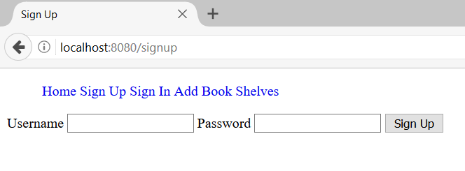

## Create Sing In Page

Create Sign In page that listen to route **/singin**. Check whether the user exists. If it exists redirect to **/home**, otherwise stay on the **same page**.

|  |
| --- |
| **SingInController.java** |
| @WebServlet(**"/signin"**) **public class** SignInController **extends** HttpServlet {   **private** UserService **userService**;   **public** SignInController() {  **this**.**userService** = **new** UserServiceImpl();  }   **protected void** doPost(HttpServletRequest request, HttpServletResponse response) **throws** ServletException, IOException {  LoginModel loginModel = **null**;  String signInText = request.getParameter(**"signin"**);  **if**(signInText != **null**){  *//****TODO Implement the logic***  }   **if**(loginModel != **null**) {  HttpSession session = request.getSession();  session.setAttribute(**"LOGIN_MODEL"**, loginModel);  response.sendRedirect(**"/"**);  } **else** {  response.sendRedirect(**"/signin"**);  }  }   **protected void** doGet(HttpServletRequest request, HttpServletResponse response) **throws** ServletException, IOException {  *//****TODO Implement the logic***  } } |

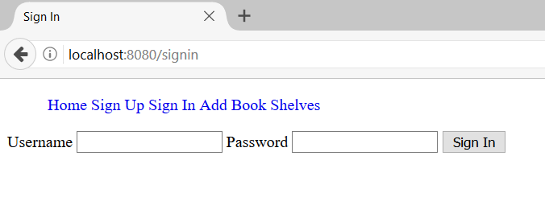

## *Create Sing Out Functionality

Crate a SignOutController that will invalidate the current session.

|  |
| --- |
| **SingOutController.java** |
| @WebServlet(**"/signout"**) **public class** SignOutController **extends** HttpServlet {   **protected void** doGet(HttpServletRequest request, HttpServletResponse response) **throws** ServletException, IOException {  HttpSession session = request.getSession();  session.invalidate();  response.sendRedirect(**"/"**);  } } |

In order to reach the controller and modify the menu.jsp to redirect to **/signout** when you are signed in.

|  |
| --- |
| **menu.jsp** |
| <**ul**>  <**li**><**a href="/"**>Home</**a**></**li**>  <**li**><**a href="/signup"**>Sign Up</**a**></**li**>  **<%** LoginModel loginModel = (LoginModel) session.getAttribute(Config.***LOGIN_MODEL***);  String username = **null**;  *//****TODO Implement the logic***  **%>** <**c:set var="username" value="${**USERNAME**}" scope="session"**/>  <**c:choose**>  <**c:when test="${**username != **null}"**>  *//****TODO Implement the logic***  </**c:when**>  <**c:otherwise**>  *//****TODO Implement the logic***  </**c:otherwise**>  </**c:choose**>  <**li**><**a href="/add"**>Add Book</**a**></**li**>  <**li**><**a href="/shelves"**>Shelves</**a**></**li**> </**ul**> |

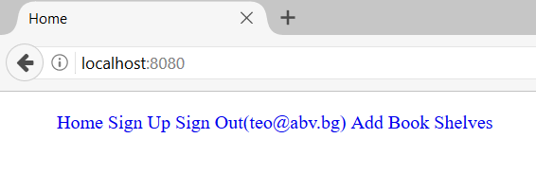

## Create Add Book Page

The page should take basic input and save the book in **the list we use as a database**. It should listen to route **/add.**

|  |
| --- |
| **AddBookController.java** |
| @WebServlet(**"/add"**) **public class** AddBookController **extends** HttpServlet {   **private** BookService **bookService**;   **public** AddBookController() {  **this**.**bookService** = **new** BookServiceImpl();  }   @Override  **protected void** doGet(HttpServletRequest req, HttpServletResponse resp) **throws** ServletException, IOException {  *//****TODO Implement the logic***  }   @Override  **protected void** doPost(HttpServletRequest req, HttpServletResponse resp) **throws** ServletException, IOException {  String add = req.getParameter(**"add"**);  **if** (add != **null**) {  *//****TODO Implement the logic***  }  } } |

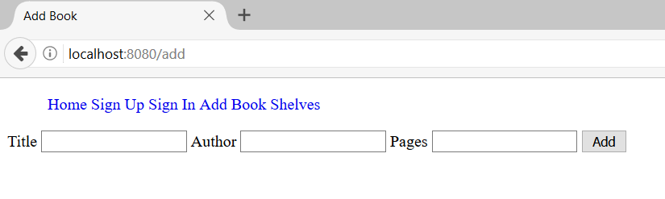

## Create Shelves Page

The page should list all the books in **the list we use as a database**. It should listen to route **/shelves.** Besides ViewBookModel properties add two additional:

* **Edit – it should refer /shelves/edit/{book name}**
* **Delete – it should refer /shelves/delete/{book name}**

|  |
| --- |
| **ShelfController.java** |
| @WebServlet(**"/shelves"**) **public class** ShelfController **extends** HttpServlet {   **private** BookService **bookService**;   **public** ShelfController() {  **this**.**bookService** = **new** BookServiceImpl();  }   @Override  **protected void** doGet(HttpServletRequest req, HttpServletResponse resp) **throws** ServletException, IOException {  List<ViewBookModel> viewBookModels = **this**.**bookService**.getAllBooks();  *//****TODO Implement the logic***  } } |

|  |
| --- |
| **shelves.jsp** |
| <**table class="tb"**>  <**thead**>  <**th**>Title</**th**>  <**th**>Author</**th**>  <**th**>Pages</**th**>  <**th**>Edit Book</**th**>  <**th**>Delete Book</**th**>  </**thead**>  <**tbody**>  <**c:set var="books" value="${**books**}"** />  <**c:forEach var="book" items="${**books**}"**>  <**tr**>  <**td**>  <**c:out value="${**book.title**}"**/>  </**td**>  *//****TODO Implement the logic***  <**td**>  <**a href="/shelves/edit/${**book.title**}"**>Edit</**a**>  </**td**>  *//****TODO Implement the logic***  </**tr**>  </**c:forEach**>  </**tbody**> </**table**> |

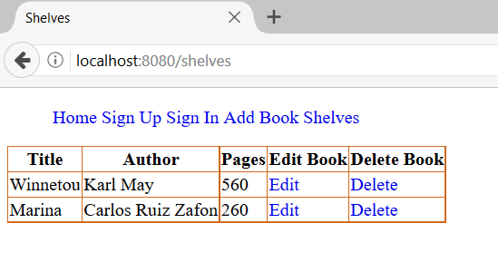

## *Create Edit Functionality

Create a controller that will listen to route **/shelves/edit/{book name}**. If the edit is done redirect to **/shelves**.

|  |
| --- |
| **EditBookController.java** |
| @WebServlet(**"/shelves/edit/*"**) **public class** EditBookController **extends** HttpServlet {   **private** BookService **bookService**;   **public** EditBookController() {  **this**.**bookService** = **new** BookServiceImpl();  }   @Override  **protected void** doGet(HttpServletRequest req, HttpServletResponse resp) **throws** ServletException, IOException {  String tokens[] = req.getRequestURI().split(**"/"**);  String title = URLDecoder.*decode*(tokens[3], **"UTF-8"**);  ViewBookModel viewBookModel = **this**.**bookService**.findBookByTitle(title);  **if**(viewBookModel != **null**){  *//****TODO Implement the logic***  }  }   @Override  **protected void** doPost(HttpServletRequest req, HttpServletResponse resp) **throws** ServletException, IOException {  String edit = req.getParameter(**"edit"**);  **if**(edit != **null**){  *//****TODO Implement the logic***  }  } } |

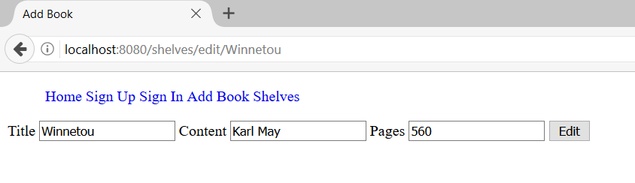

## *Create Delete Functionality

Create a controller that will listen to route **/shelves/delete/{book name}**. If the edit is done redirect to **/shelves**.

|  |
| --- |
| **DeleteBookController.java** |
| @WebServlet(**"/shelves/delete/*"**) **public class** DeleteBookController **extends** HttpServlet {   **private** BookService **bookService**;   **public** DeleteBookController() {  **this**.**bookService** = **new** BookServiceImpl();  }   @Override  **protected void** doGet(HttpServletRequest req, HttpServletResponse resp) **throws** ServletException, IOException {  *//****TODO Implement the logic***  } } |

